Mathematical Representation

🌟 Definition
# Source: AI Source: Provided by: [Data Path: Persons Table -> ID Column: 1, Name_En Column: Motasem Essam] -> From: [ChatGPT] on [5/29/2026]
Mathematical representation is the way mathematical ideas, objects, relationships, or real-world situations are expressed using mathematical language, symbols, diagrams, graphs, equations, or models.
It is how we “translate” something into mathematics so it can be analyzed and solved.

🎯 Purpose of Mathematical Representation
# Source: AI Source: Provided by: [Data Path: Persons Table -> ID Column: 1, Name_En Column: Motasem Essam] -> From: [ChatGPT] on [5/29/2026]
- To convert real-world problems into mathematical form
- To make complex ideas easier to understand
- To analyze patterns and relationships
- To solve problems using mathematical tools
- To communicate ideas clearly and precisely

📚 Main Types of Mathematical Representation

1. Symbolic Representation
# Source: AI Source: Provided by: [Data Path: Persons Table -> ID Column: 1, Name_En Column: Motasem Essam] -> From: [ChatGPT] on [5/29/2026]
Uses symbols and equations.
$$x+y=10$$
Used in algebra, equations, and formulas.

2. Numerical Representation
# Source: AI Source: Provided by: [Data Path: Persons Table -> ID Column: 1, Name_En Column: Motasem Essam] -> From: [ChatGPT] on [5/29/2026]
Uses numbers and calculations.
Example:
- 25, 3.14, -7
Used in arithmetic and data.

3. Graphical Representation
# Source: AI Source: Provided by: [Data Path: Persons Table -> ID Column: 1, Name_En Column: Motasem Essam] -> From: [ChatGPT] on [5/29/2026]
Uses graphs and diagrams.
Example:
- Coordinate graphs
- Bar charts
- Line graphs
Used to visualize relationships.

4. Geometric Representation
# Source: AI Source: Provided by: [Data Path: Persons Table -> ID Column: 1, Name_En Column: Motasem Essam] -> From: [ChatGPT] on [5/29/2026]
Uses shapes and spatial figures.
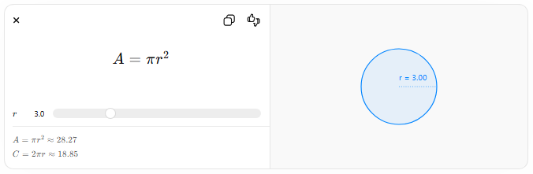
$$A=πr^{2}$$
$$r$$
$$A=πr^{2}≈28.27$$
$$C=2πr≈18.85$$
r = 3.00
Used in geometry and spatial problems.

5. Logical Representation
# Source: AI Source: Provided by: [Data Path: Persons Table -> ID Column: 1, Name_En Column: Motasem Essam] -> From: [ChatGPT] on [5/29/2026]
Uses logical statements and reasoning.
$$∀x, x>0⇒x^{2}>0$$
Used in mathematical logic and proofs.

6. Tabular Representation
# Source: AI Source: Provided by: [Data Path: Persons Table -> ID Column: 1, Name_En Column: Motasem Essam] -> From: [ChatGPT] on [5/29/2026]
Uses tables to organize data.
Example:
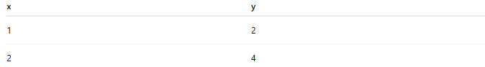
x | y
1 | 2
2 | 4

🧩 Examples of Mathematical Representation

Example 1: Real-life situation
# Source: AI Source: Provided by: [Data Path: Persons Table -> ID Column: 1, Name_En Column: Motasem Essam] -> From: [ChatGPT] on [5/29/2026]
Statement: A car travels 60 km per hour.
Mathematical representation:
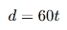
$$d=60t$$

Example 2: Geometry
# Source: AI Source: Provided by: [Data Path: Persons Table -> ID Column: 1, Name_En Column: Motasem Essam] -> From: [ChatGPT] on [5/29/2026]
A circle:
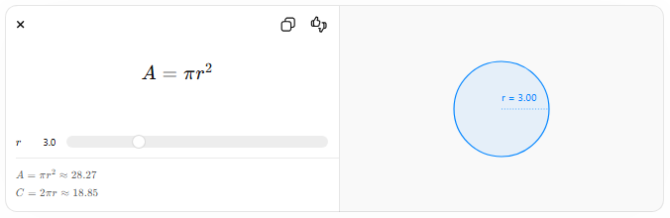
$$A=πr^{2}$$
$$r$$
$$A=πr^{2}≈28.27$$
$$C=2πr≈18.85$$
r = 3.00

Example 3: Logic
# Source: AI Source: Provided by: [Data Path: Persons Table -> ID Column: 1, Name_En Column: Motasem Essam] -> From: [ChatGPT] on [5/29/2026]
“All humans are mortal”
$$∀x(Human(x)→Mortal(x))$$

🔗 Relationship to Other Concepts
# Source: AI Source: Provided by: [Data Path: Persons Table -> ID Column: 1, Name_En Column: Motasem Essam] -> From: [ChatGPT] on [5/29/2026]
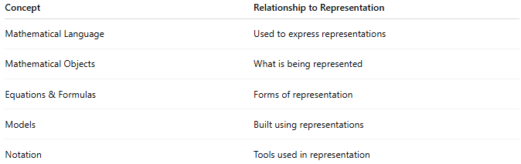
Concept | Relationship to Representation
Mathematical Language | Used to express representations
Mathematical Objects | What is being represented
Equations & Formulas | Forms of representation
Models | Built using representations
Notation | Tools used in representation

📖 Representation vs Notation vs Model
# Source: AI Source: Provided by: [Data Path: Persons Table -> ID Column: 1, Name_En Column: Motasem Essam] -> From: [ChatGPT] on [5/29/2026]
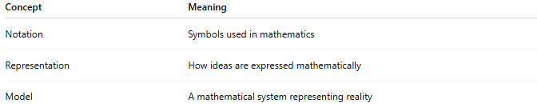
Concept | Meaning
Notation | Symbols used in mathematics
Representation | How ideas are expressed mathematically
Model | A mathematical system representing reality

🧠 Simple Analogy
# Source: AI Source: Provided by: [Data Path: Persons Table -> ID Column: 1, Name_En Column: Motasem Essam] -> From: [ChatGPT] on [5/29/2026]
Mathematical representation is like a translation system:
- Real-world situation → mathematics
- Words → equations, graphs, symbols
- Idea → mathematical model

🧭 Simple Summary
# Source: AI Source: Provided by: [Data Path: Persons Table -> ID Column: 1, Name_En Column: Motasem Essam] -> From: [ChatGPT] on [5/29/2026]
Mathematical representation is the process of expressing real-world situations or abstract ideas using mathematical symbols, equations, graphs, or models so they can be analyzed and solved using mathematics.

